**JavaScript:**

JavaScript is programming language which you can use to create any kind of application such as web application, mobile application etc.

In 1995, when the javascript was launched it was basically for the frontend. In 1993, when the websites were getting famous. Everyone wanted their own websites but at that time websites were not interactive means it’s one way interaction means if you need something then in response you get a static page as output. So, if you want your audience engaged then you should make your website interactive, so Netscape comes with the approach of javascript with the help of sun microsystem but that time javascript was only for web frontend. Now, things get changed over the time, people start talking about can we use javascript as backend language? They were able to do it because of engine. Every browser has engine as we know javascript was web server language, we can run it in browser because of engine so we just pick that engine on local machine and now we can use javascript on any machine. Nodejs is the example which provides run time environment on local machine.

In browser, we can use engine like:

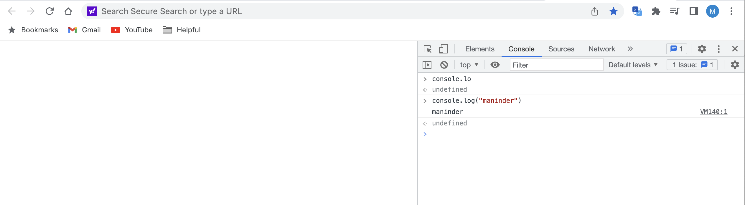

When can we run code here so why there is a need of run javascript code on local machine?

Ans is no code has only one line to run. Here we are just doing one line of code. Secondly, we can copy paste the code if we have more lines of code but that is not a best practice to do coding. We can run javascript code on local machine with the help of node.

Install the node and run the js file which we want to run:

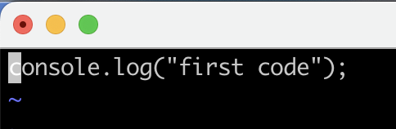



We install the vs code for javascript language. By default, there is no option for run code without executing it inside the terminal.

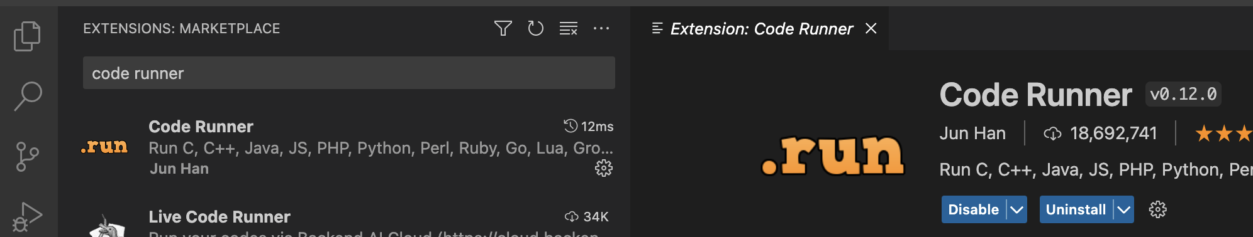

So, we have installed the code runner, now we have a functionality of run button:

You can see on the top right side there is an option of run button:

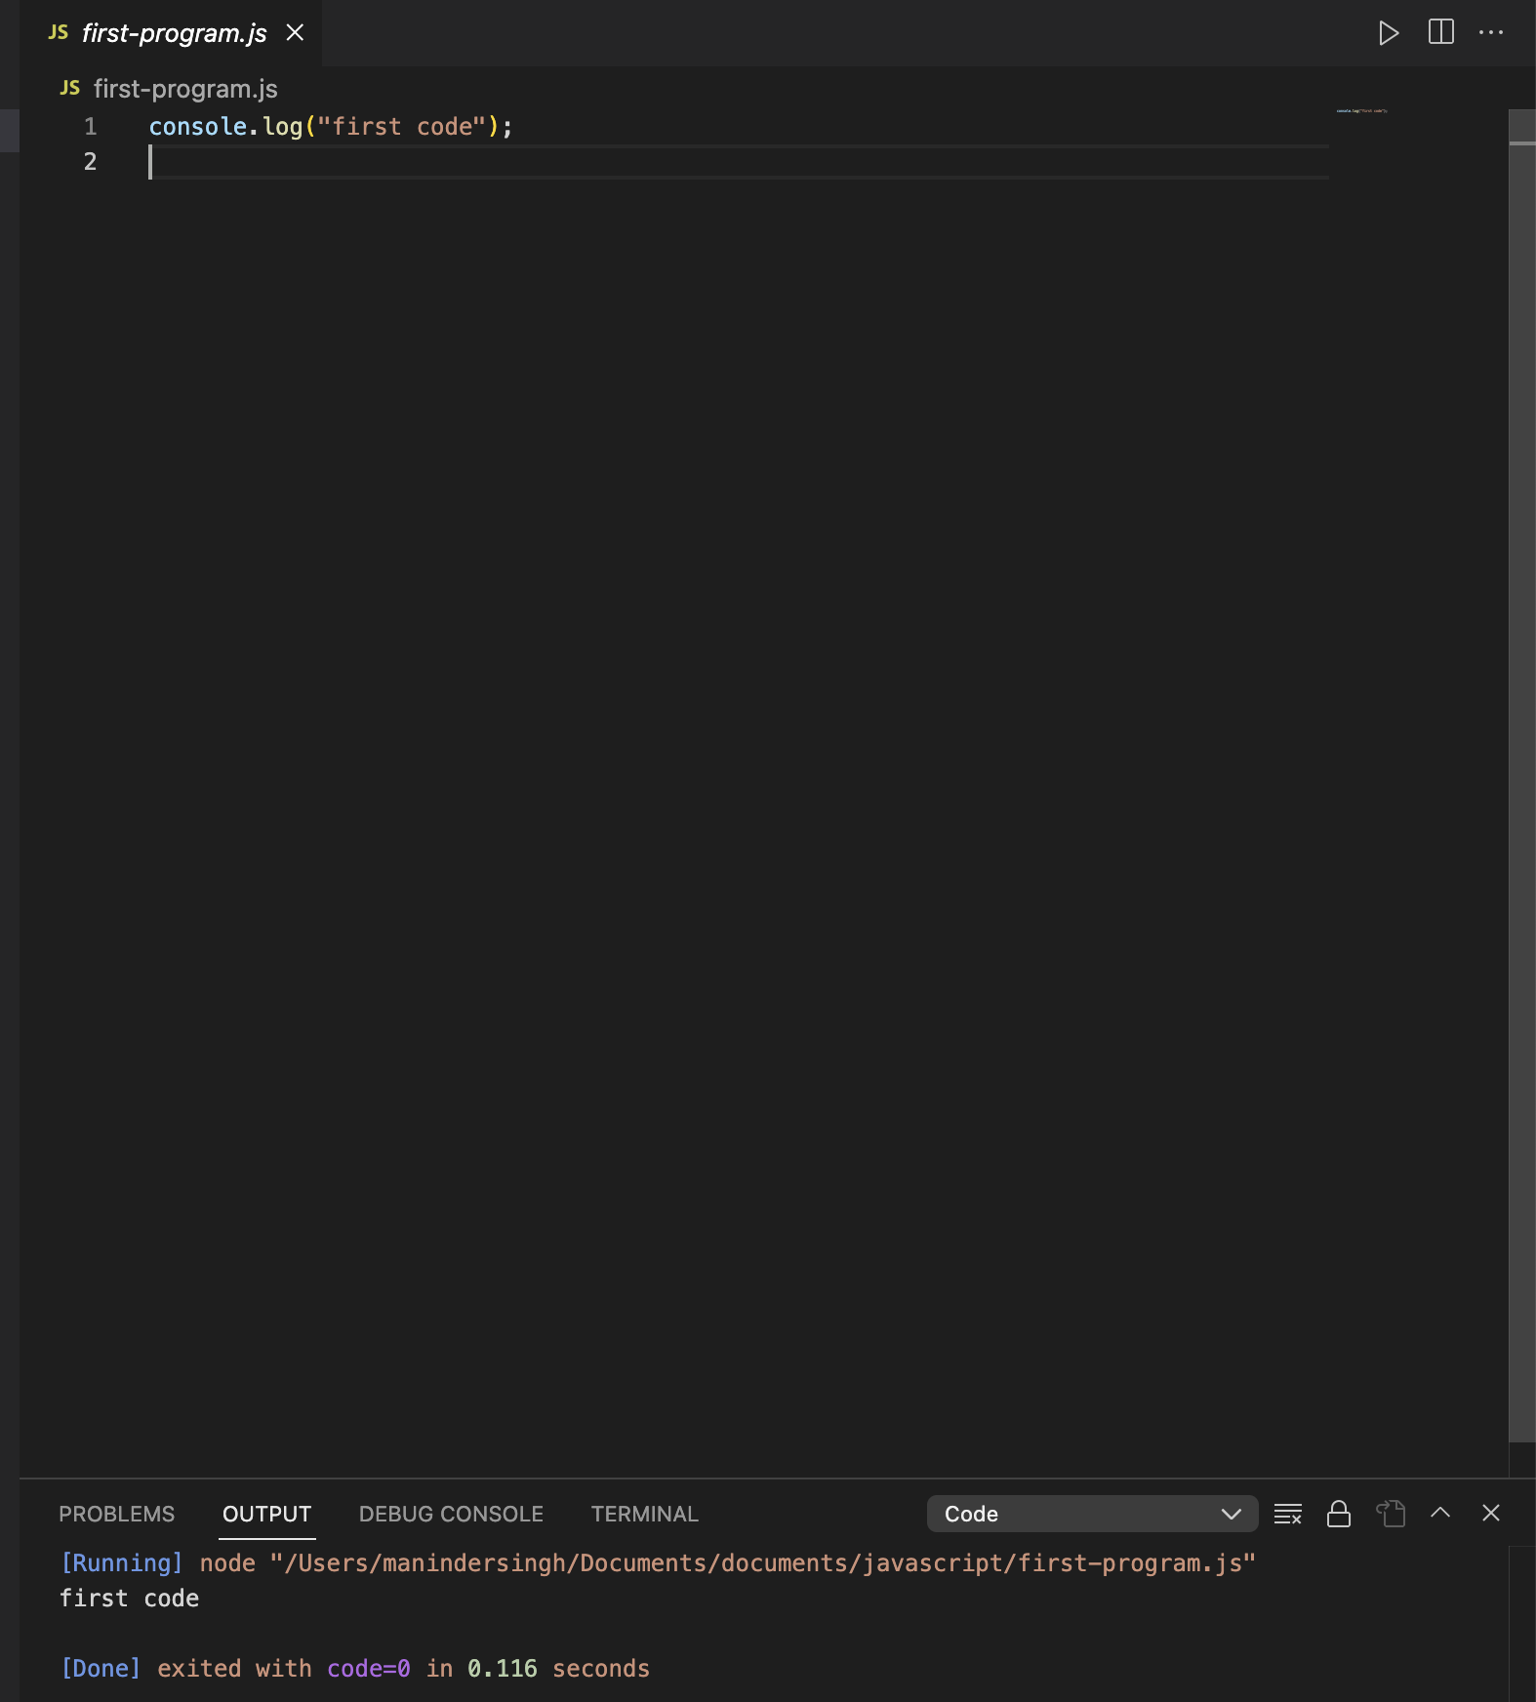

**Variable:** To store data we use variable:

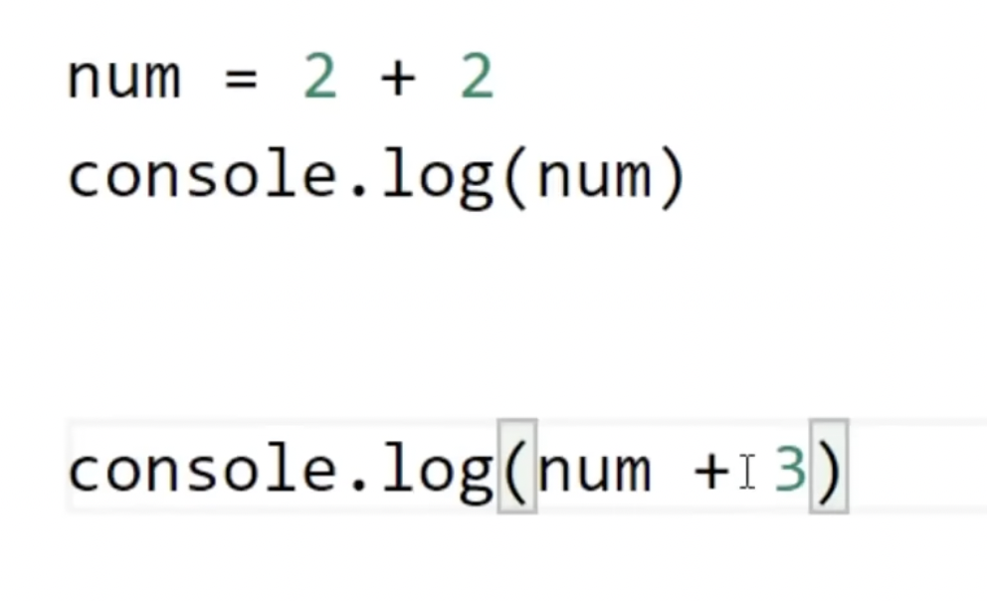

Previously, we defined variable as mentioned above but it’s not a good way to declare it. Use **let** keyword to store the variables.

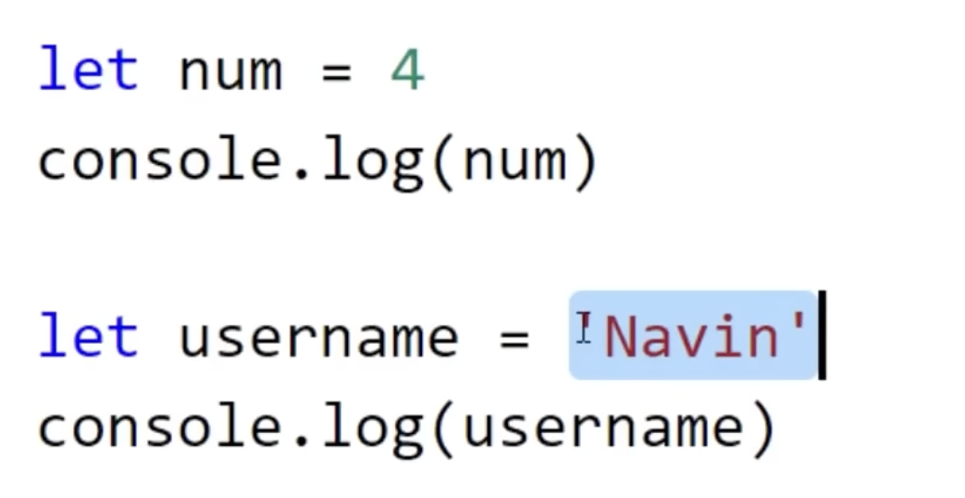

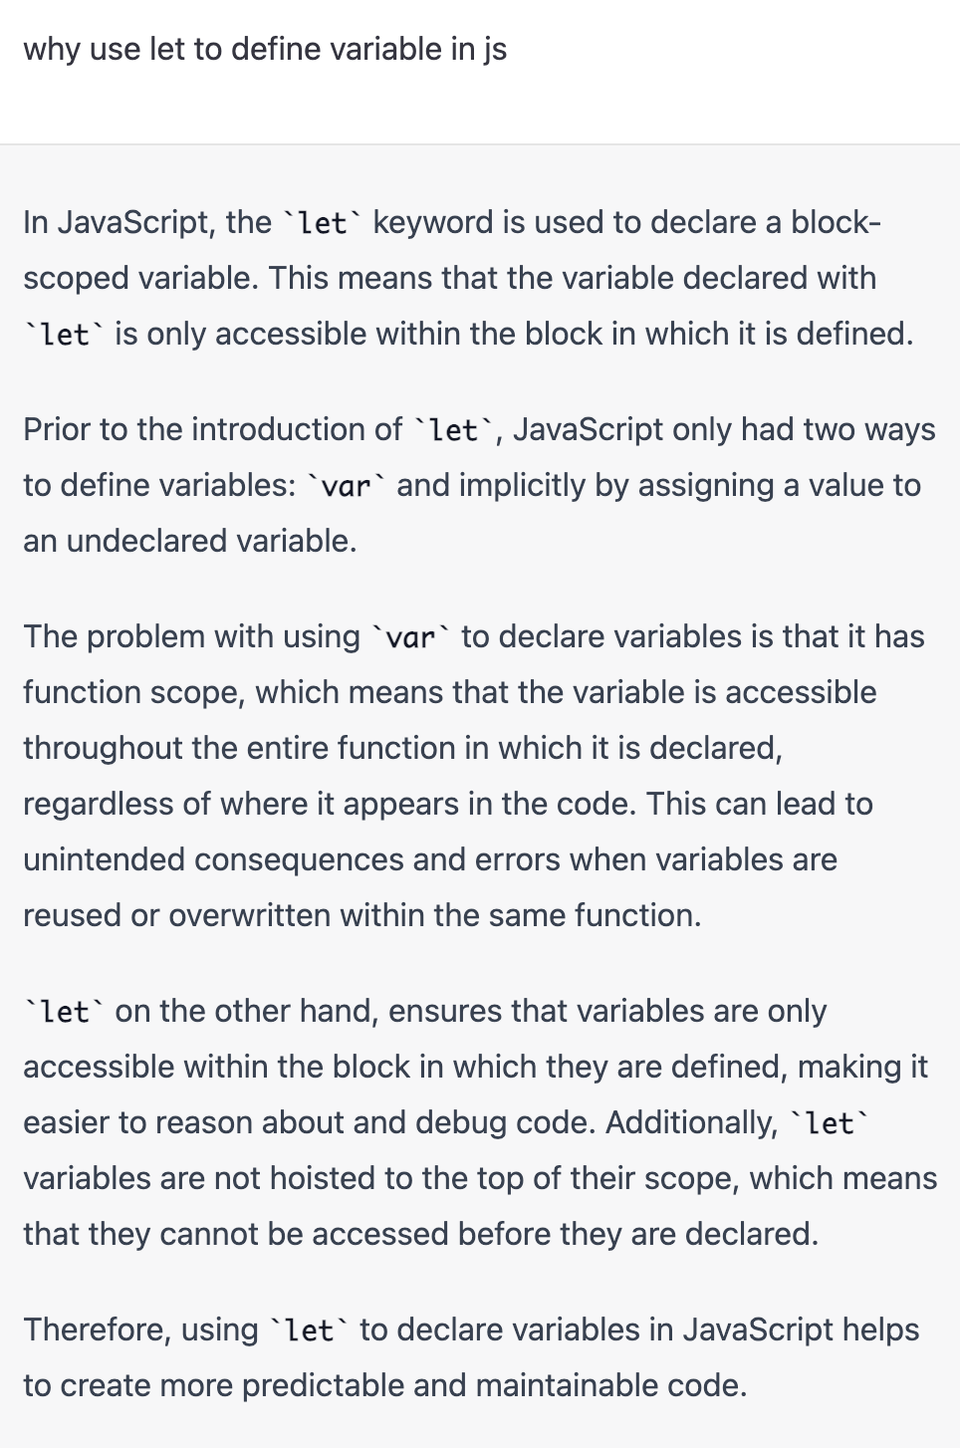

**Constant:** When we know that this value will never changes it’s good to mark that variable as constant. Suppose we know the value of “pi=3.14” and its constant value so mark this value as constant so that no one can change it.

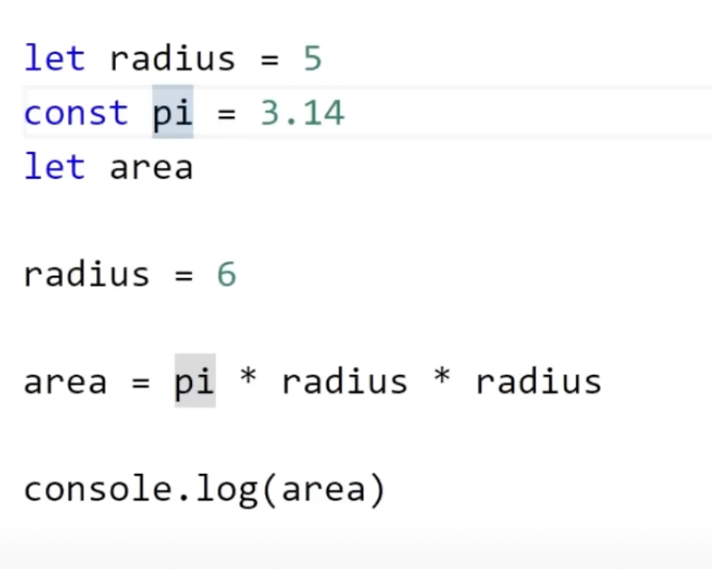

**Node js:**

In short, it’s javascript run time environment which use v8 engine launched by chrome.

As explained above node js is java script engine that helps us to run javascript on local machine. Now we can run javascript on local. Now, what if we can add http module inside node js. So, now we have power to use javascript along with these modules. Some modules are in built and some modules are third party we can use for our cases. Now, we can do everything with the help of javascript like fronted, backend whatever we want to do.

**So, question comes into our mind which framework we are going to use for node?**

Like in java we use spring and python we use Django so in the case of node we will use **Express** framework. We can use react or angular as a fronted with it to build the entire application.



So, we can use full stack application using javascript. Apart from this there is concept of **npm** in javascript. NPM: node package manager it’s like pom dependency in spring boot.



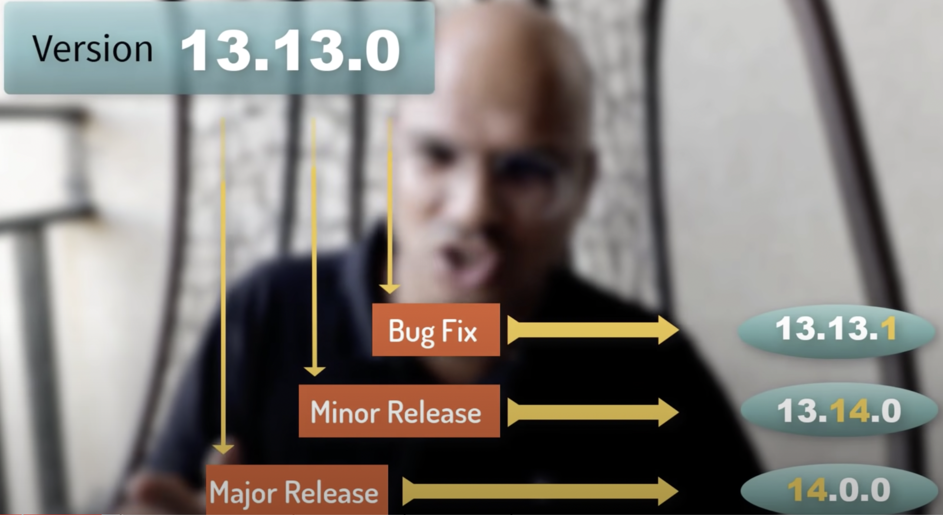

**http Service in node js:**

Node.js has a built-in module called HTTP, which allows Node.js to transfer data over the Hyper Text Transfer Protocol (HTTP).

To include the HTTP module, use the “**require**()” method:

in this code, we have imported the http module.

Creating the server in which passing request and response.

Want response as output and output is the print statement.

We want to print only one line of code so just saying that “**response.end**”, otherwise it thinks still you want to add more lines of code.

We want to listen to it on port

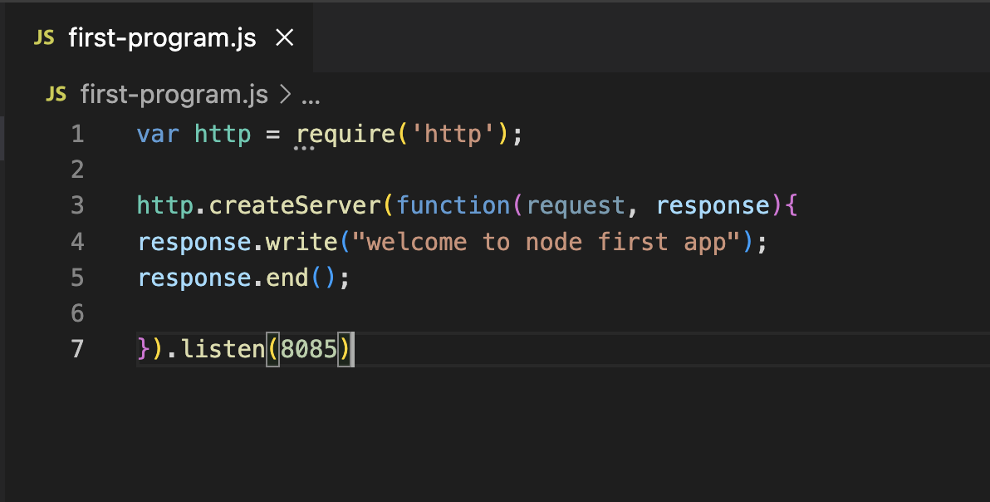

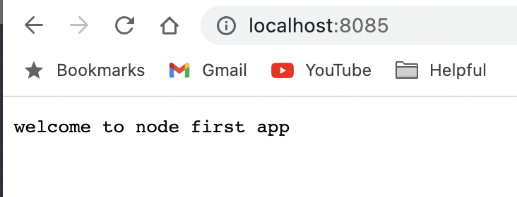

If you want to pass the headers in code and only have one line of code:

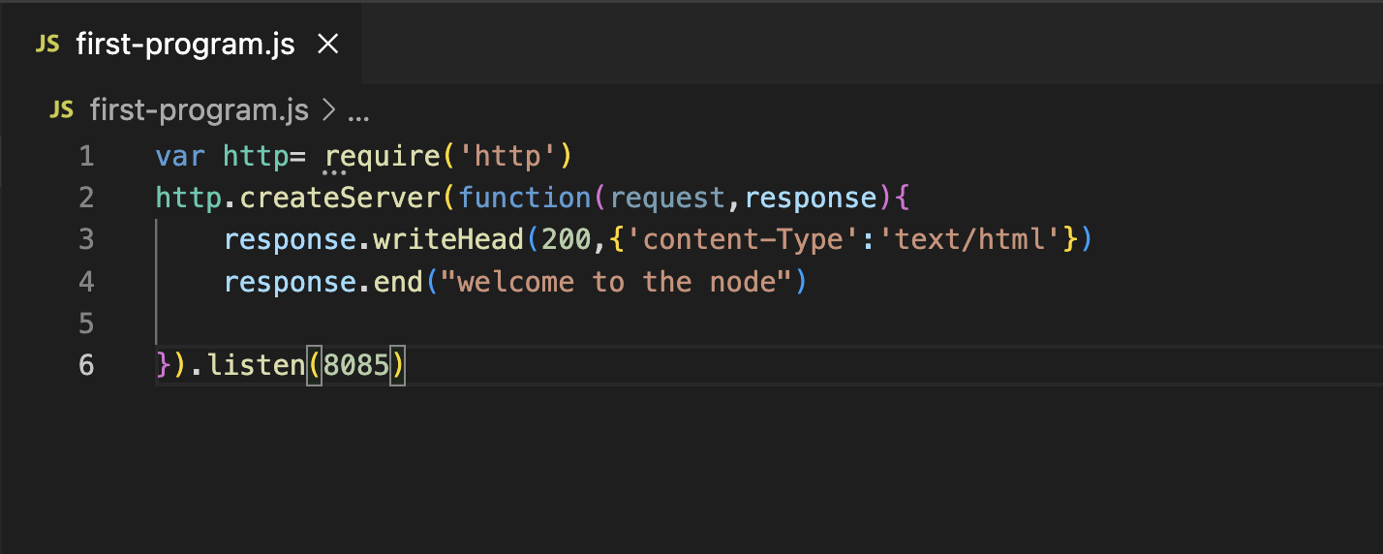

**NPM: node package manager**

It manages your package. It’s same as pom dependency.

**Express** is the framework we used for node js like spring in java.

Install express:



Suppose we have created a add method like below:

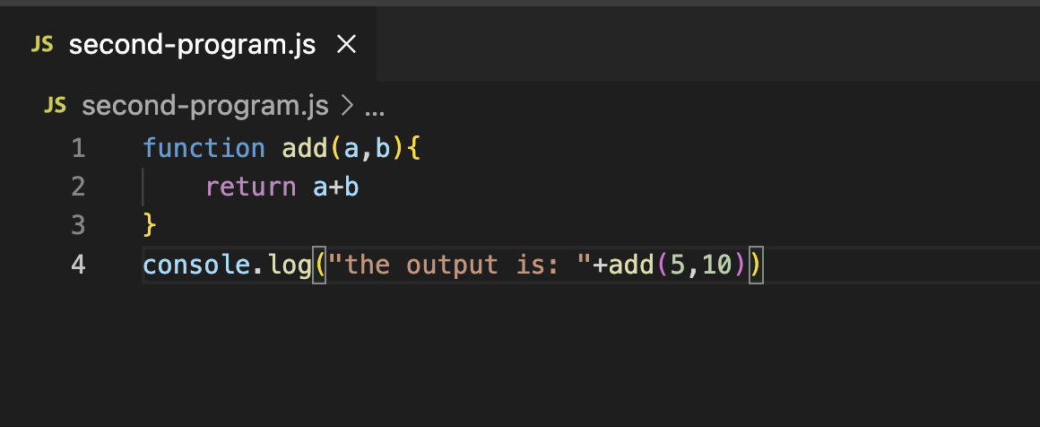

It’s working as per functionality, but we don’t want to add this function into existing js class. We only need the code that we want to run, and logic should be in another class:

We have created one more class called:

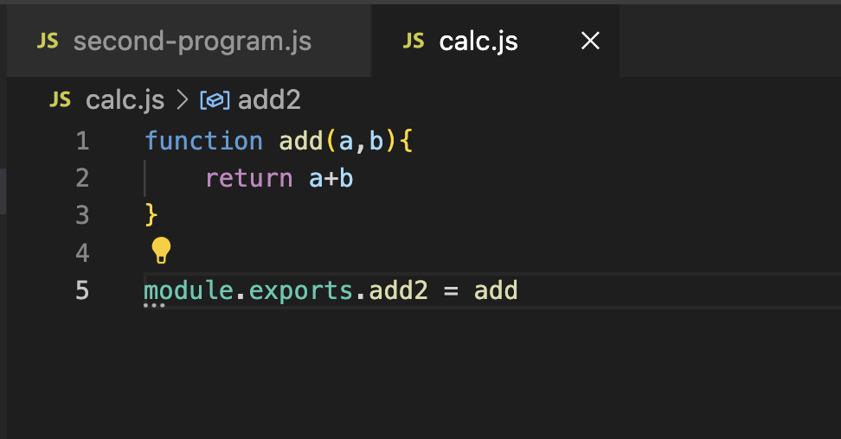

In which we mention the logic to addition of 2 numbers. But line 5 is important without this line we cannot call this method. Here we are telling that we are exporting this method so that other classes can use this method. So variable **add2** will call from another js classes to use this method.

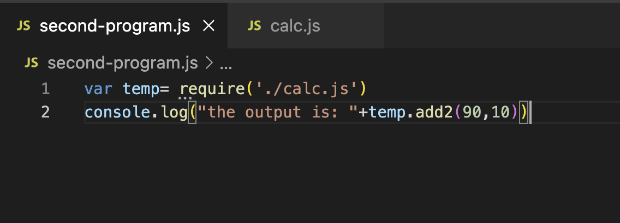

On line 2 we are calling **add2** method and will get the desire output.

Suppose if you have 2 methods then how you can call these 2 methods:

We can define like this:

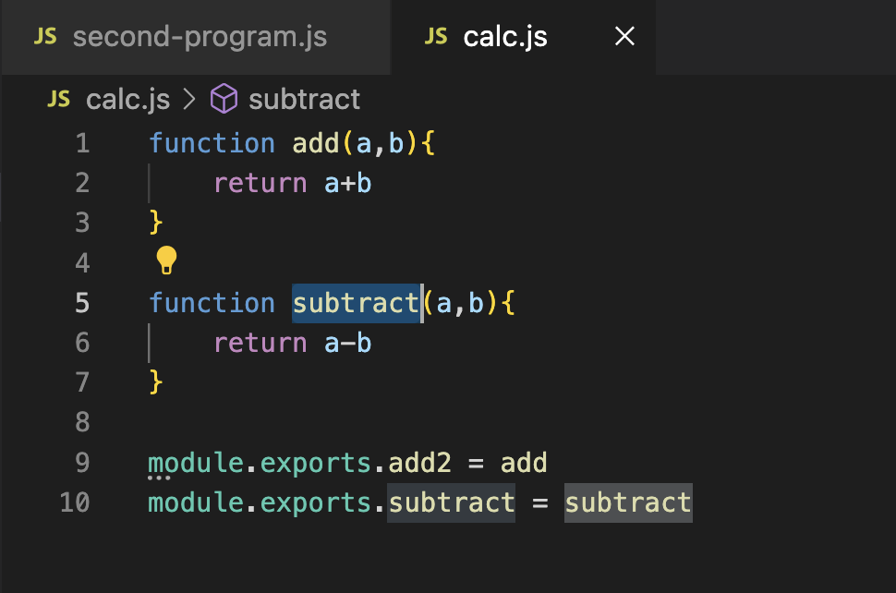

But do you think this is right approach to do like we are doing on line 9 and 10.

Added the exports statement along with function:

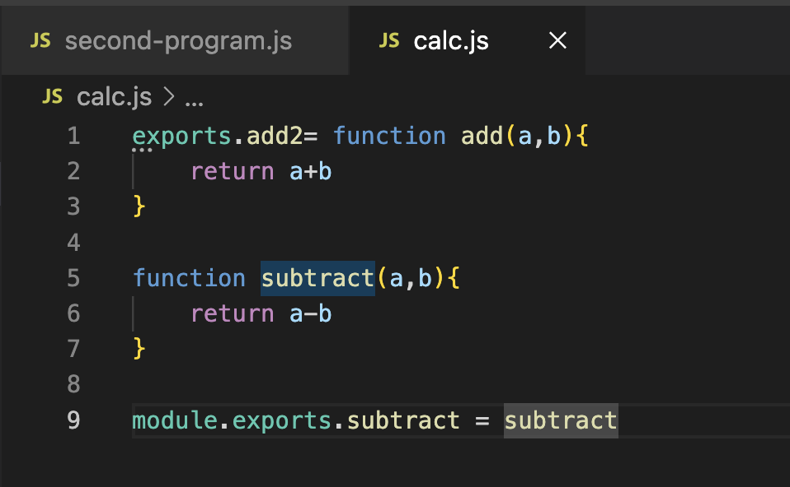

**How to read file using file system module:**

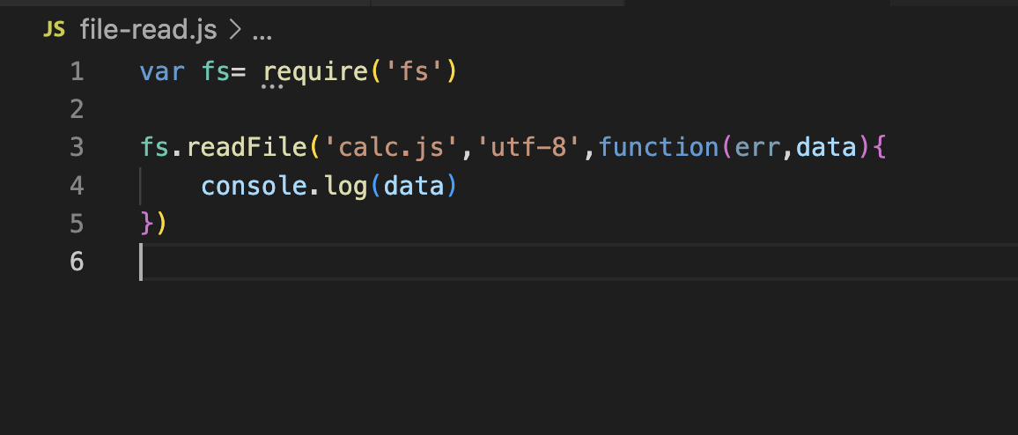

1. Importing the file system module.
2. Need to pass the file which we want to read.
3. Format type of file. “utf-8”.
4. Pass the function having 2 parameters. One is “err” and second is data. If any error comes then it stores into this err variable and if able to read the file, then you can store data inside “data” variable.

**How to write file using FS:**

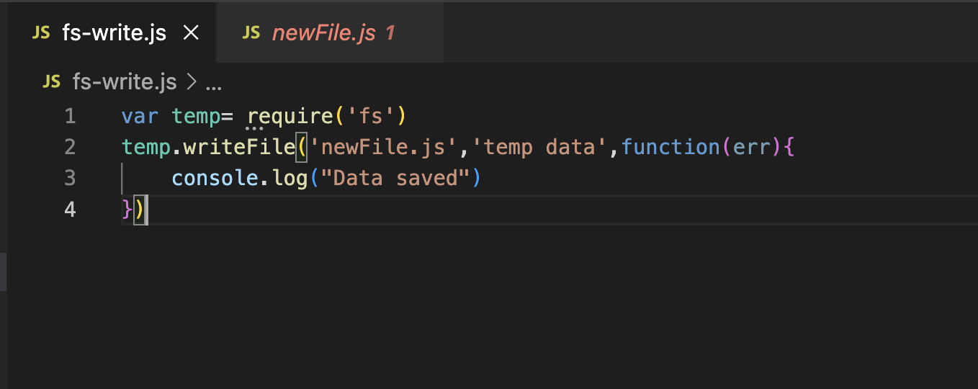

1. Providing the file name which we want
2. Data we need to store in file. Our case it’s “temp data”.
3. Function in case error come.

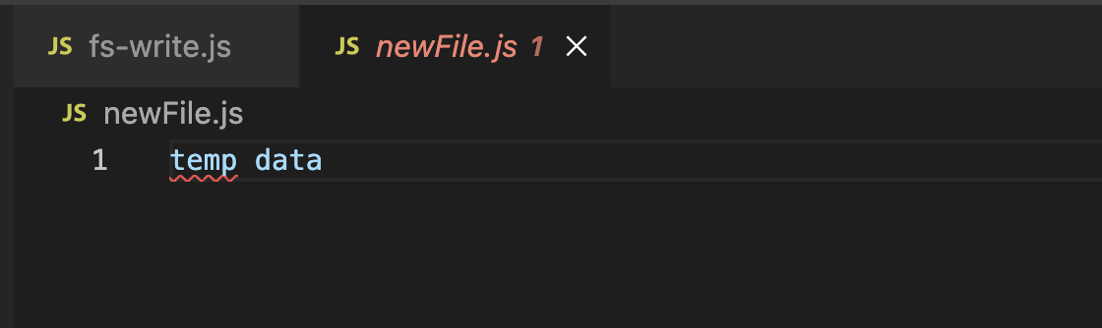

We are using writeFile function so it will replace the existing data if anything presents inside the file and added the new one but if you don’t want to delete the previously data then we can use append file option:

**Delete file:** We can use method “unlink” to delete the method

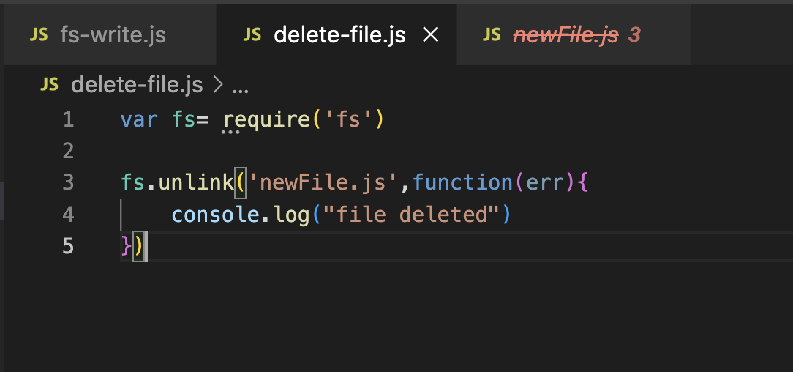

**Express js:**

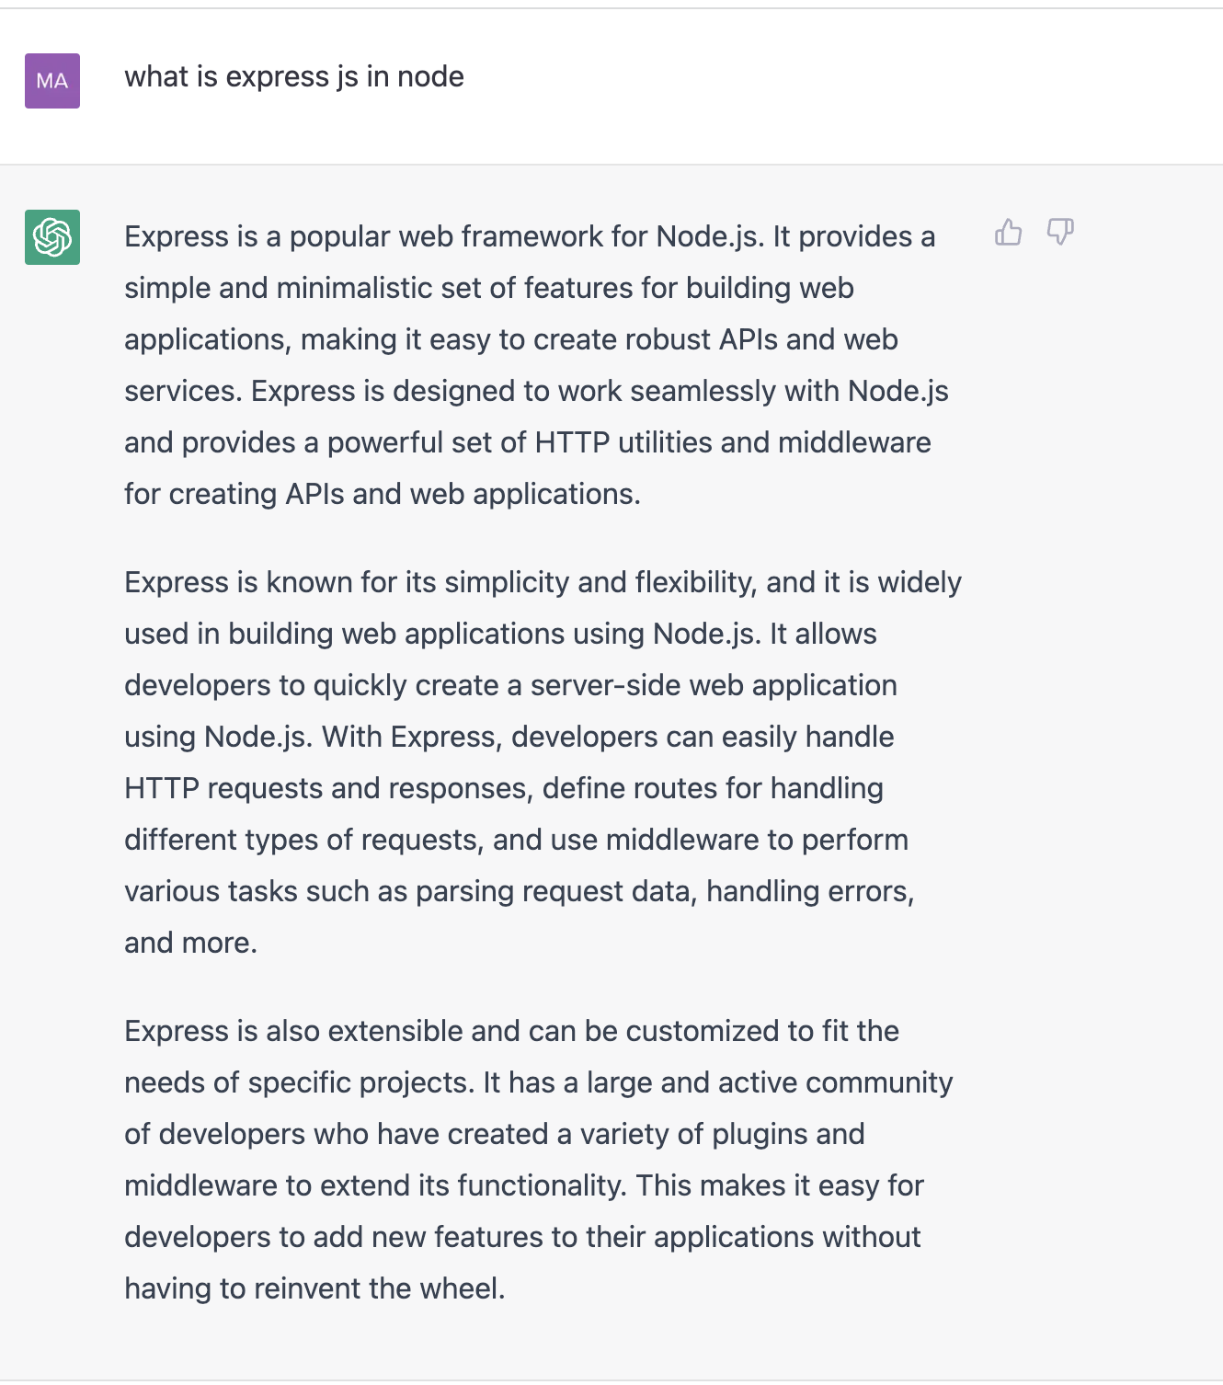

To use this:

1. Import it using require method.
2. Start it and saved the method into one parameter.
3. Use that parameter and expose the port on which you want to run the server.
4. Write your get APIs like below:

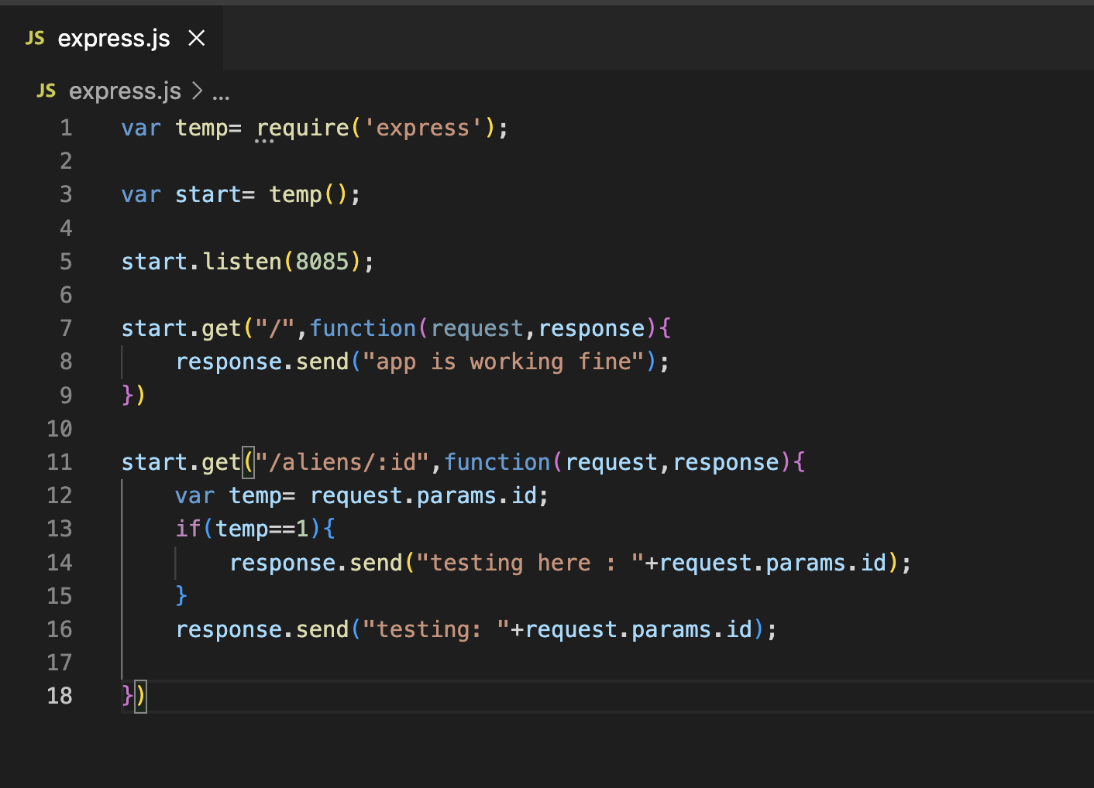

1. Here we are exposing js to 8085 ports.
2. Created 2 get methods one is for server up and second when use pass the id:

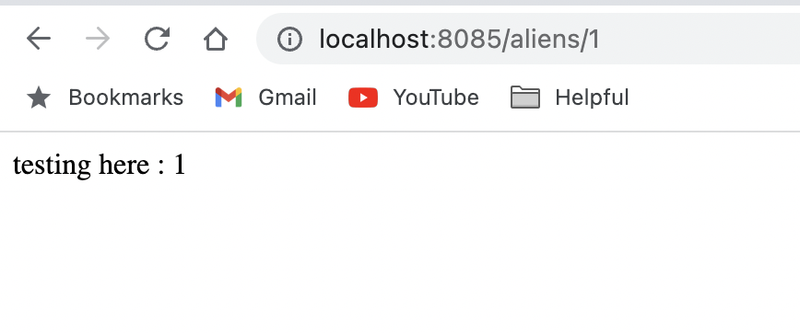

If you want to pass query parameter, then you can do like this:

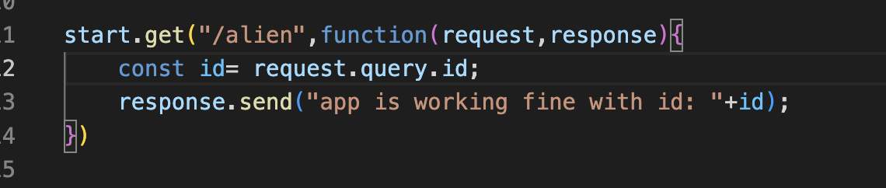

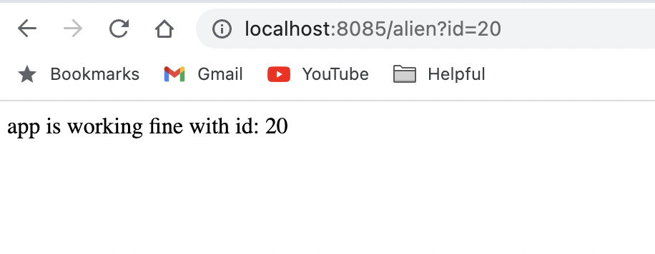

**CRUD in node:**

1. First run this command: “**npm init**”.

If you want to give this package to someone else to run their end. With this command it will create “**package.json**” file which will have all the details.

Go with default options.

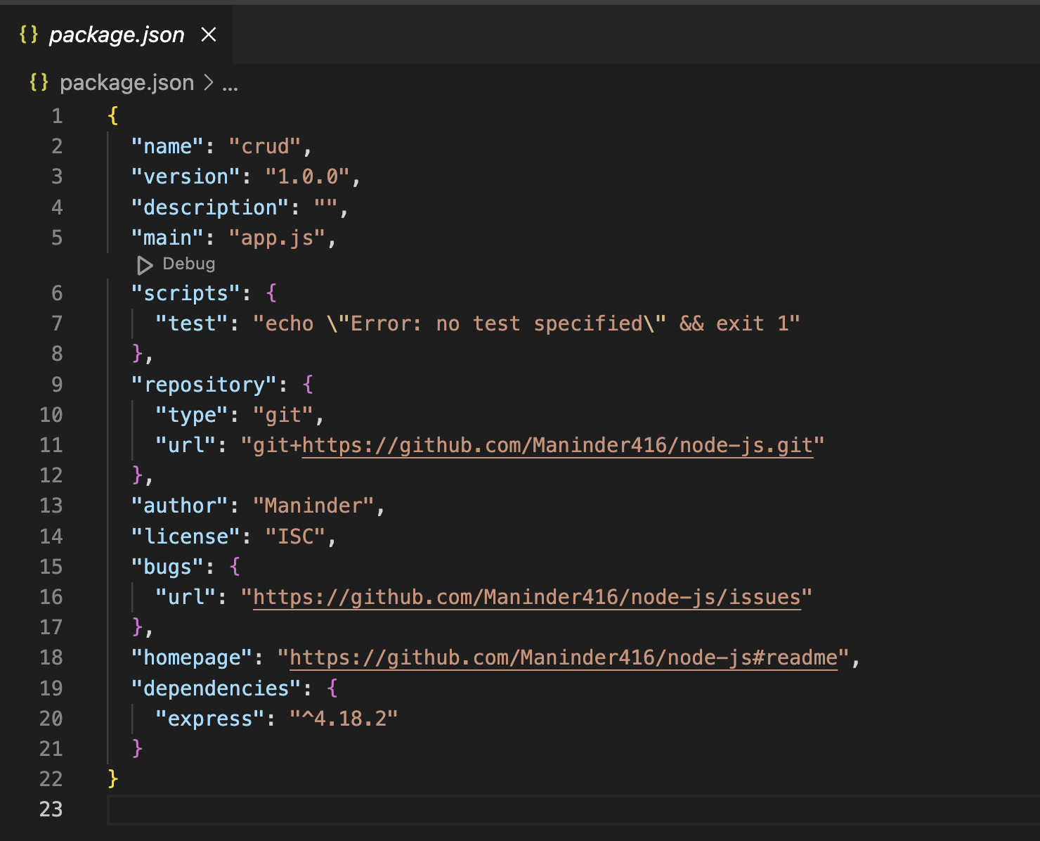

1. Install express and mongo DB, mongoose. Whatever we are installing it will add to the package.json file:

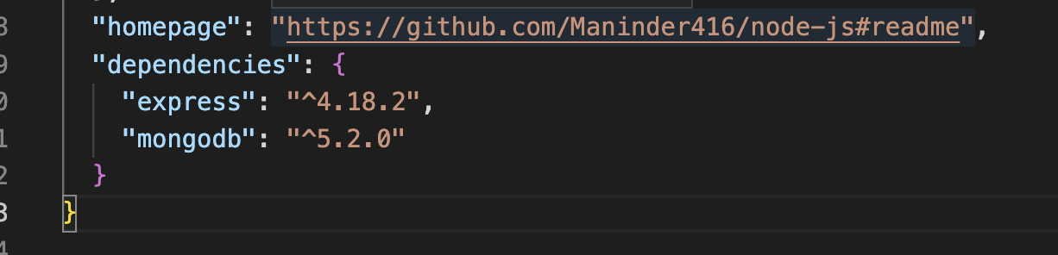

1. Installing “**nodemon**”. It is same as dev-tools in java. One more thing, as we know that we don’t want to install nodemon on production side because we don’t want to restart our production for testing purpose. It is required only for dev testing purpose so install it like this:

**npm install nodemon --save-dev**

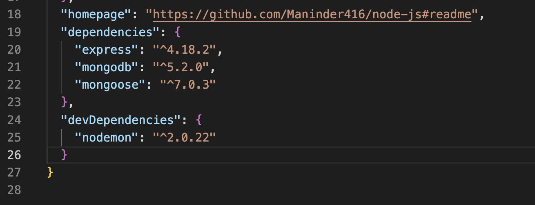

It will come under “**devDependencies**”. This “**package.json**” will install all the dependencies when we install our code on prod on the behalf of this json file.

We also need to tell it that whenever we use “**nodemon**” it will restart this js file: mention to line 7. App.js is our main file name mention in line 5.

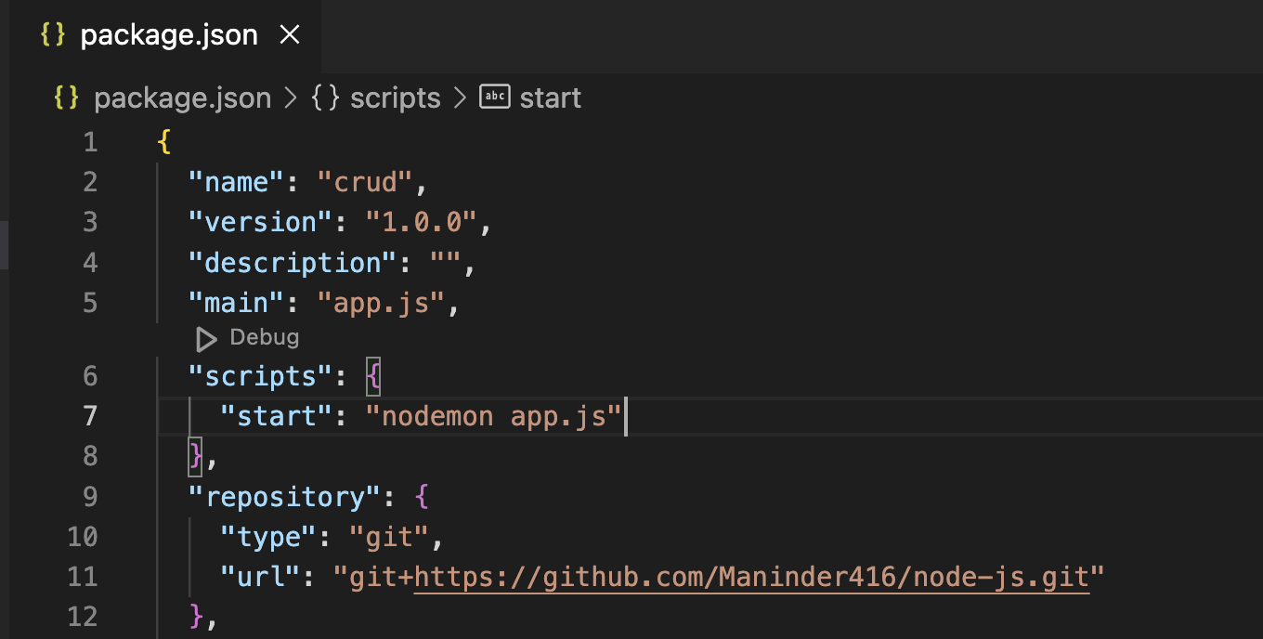

Install the mongo database on local machine. I had some issues with docker mongo so installing it locally:

brew tap mongodb/brew

brew install mongodb-community@6.0

brew services start mongodb-community@6.0

provide the URL of mongo db and try to connect it:

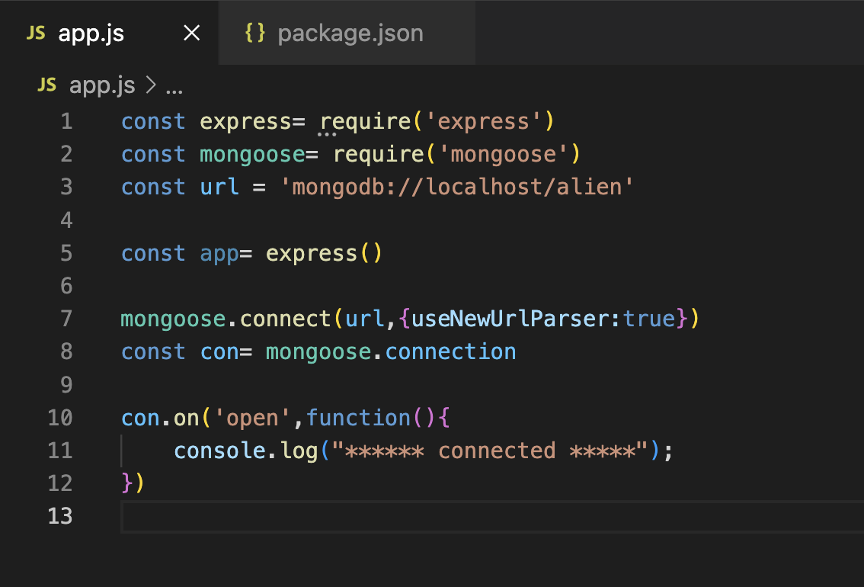

So, we are creating CRUD operation against the aliens so creating a new js file for alien.

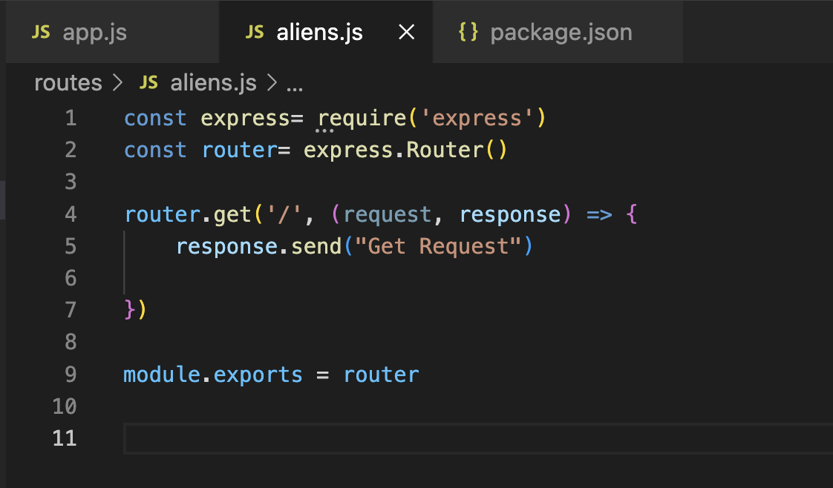

1. Import express.
2. And added the get request.
3. Export the router so that everyone can use it.

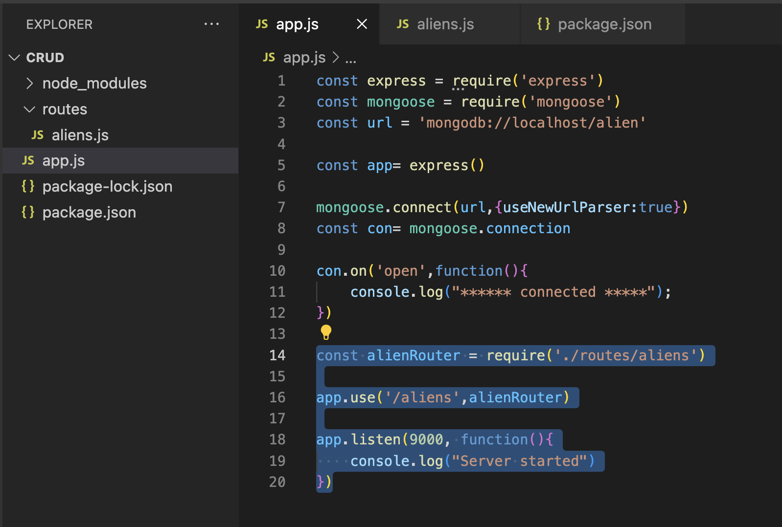

1. Here we are importing the aliens js file.
2. When get request for “/aliens” come then use this router called “**alienRouter**”.
3. Server is running on port 9000.

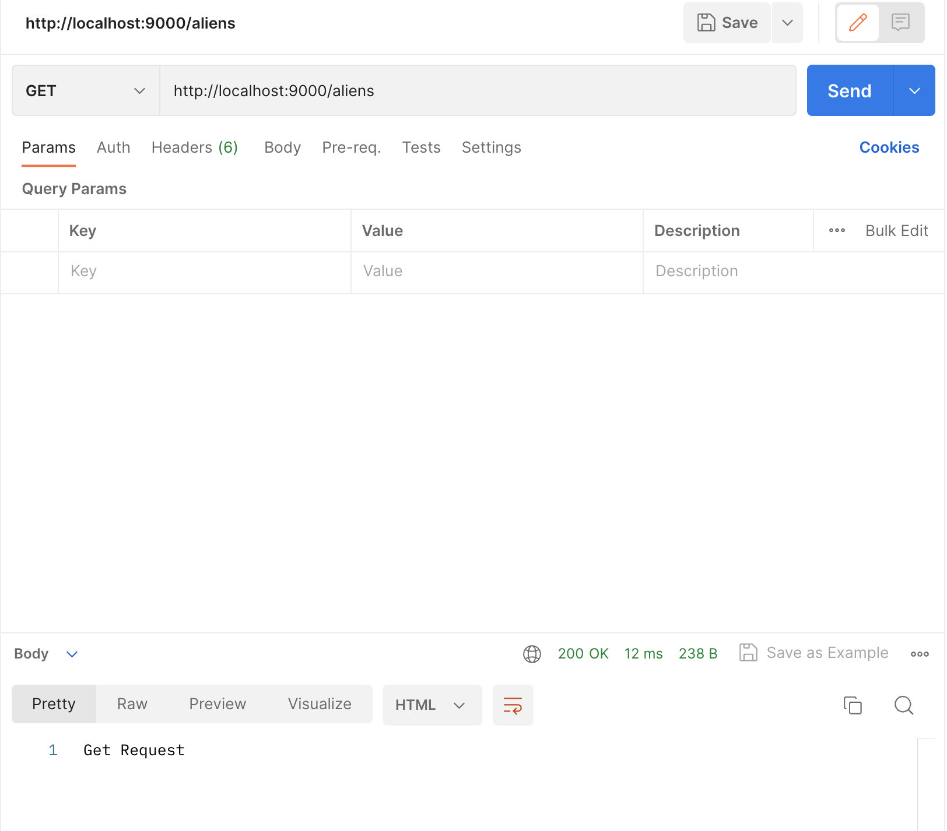

**In mongo:**

Container: db

Collection: table

Document: rows

Field: column

Meantime, we were just creating a simple get request but now we will create get request for accessing the objects from DB:

1. For this, we will create model class:

In which we mentioned name, tech, sub as parameters.

Need a export so that anyone can access it.

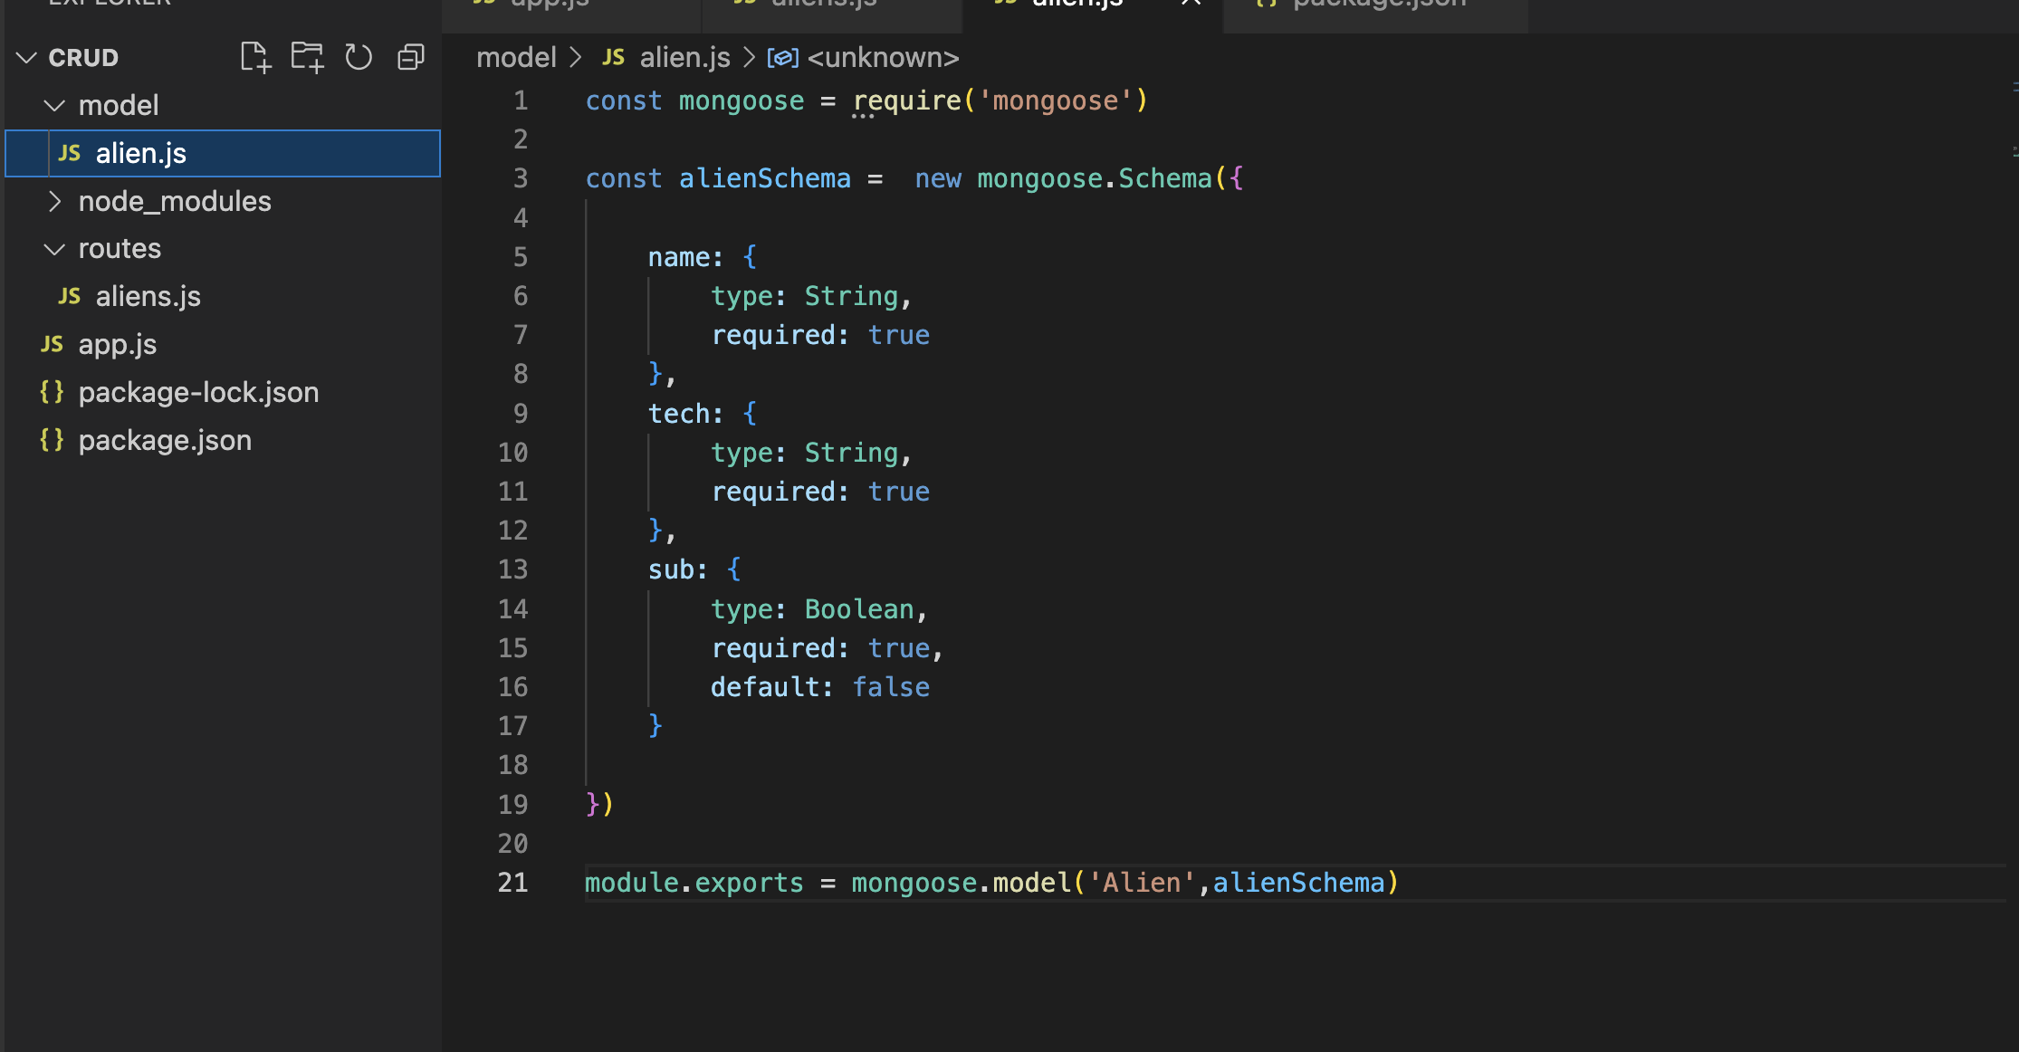

Below, we are exporting this js file on line 3 and using it in our get method.

We are using <http://localhost:9000/aliens> to access this method. When the call comes to this url then

We have mentioned in our **app.js** file that when call comes to this method then use this router. Check line no: 16 and 18. It will call our “aliens.js” controller class.

In this file, **it’s important to mention that it’s using** **json** **data like line `14`.**

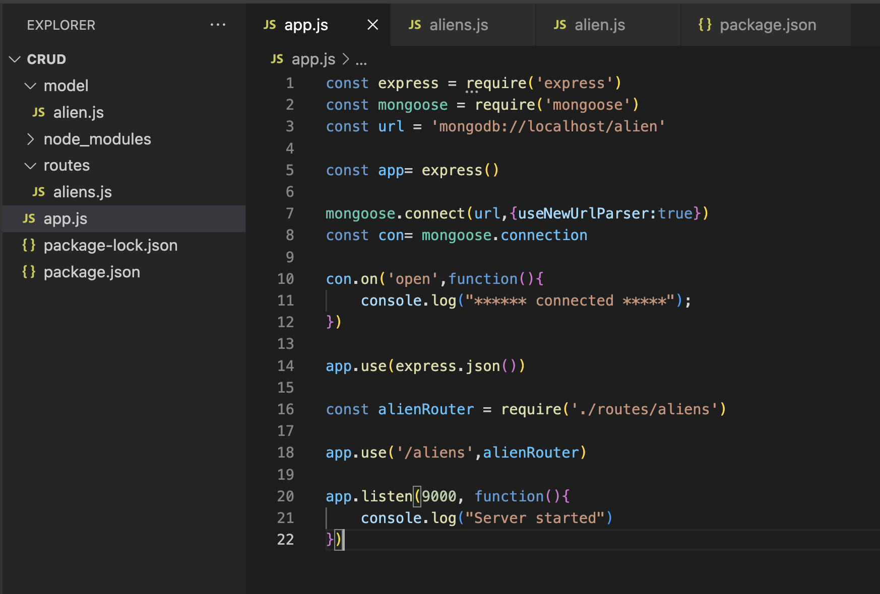

And inside our “aliens.js” file we have defined get method:

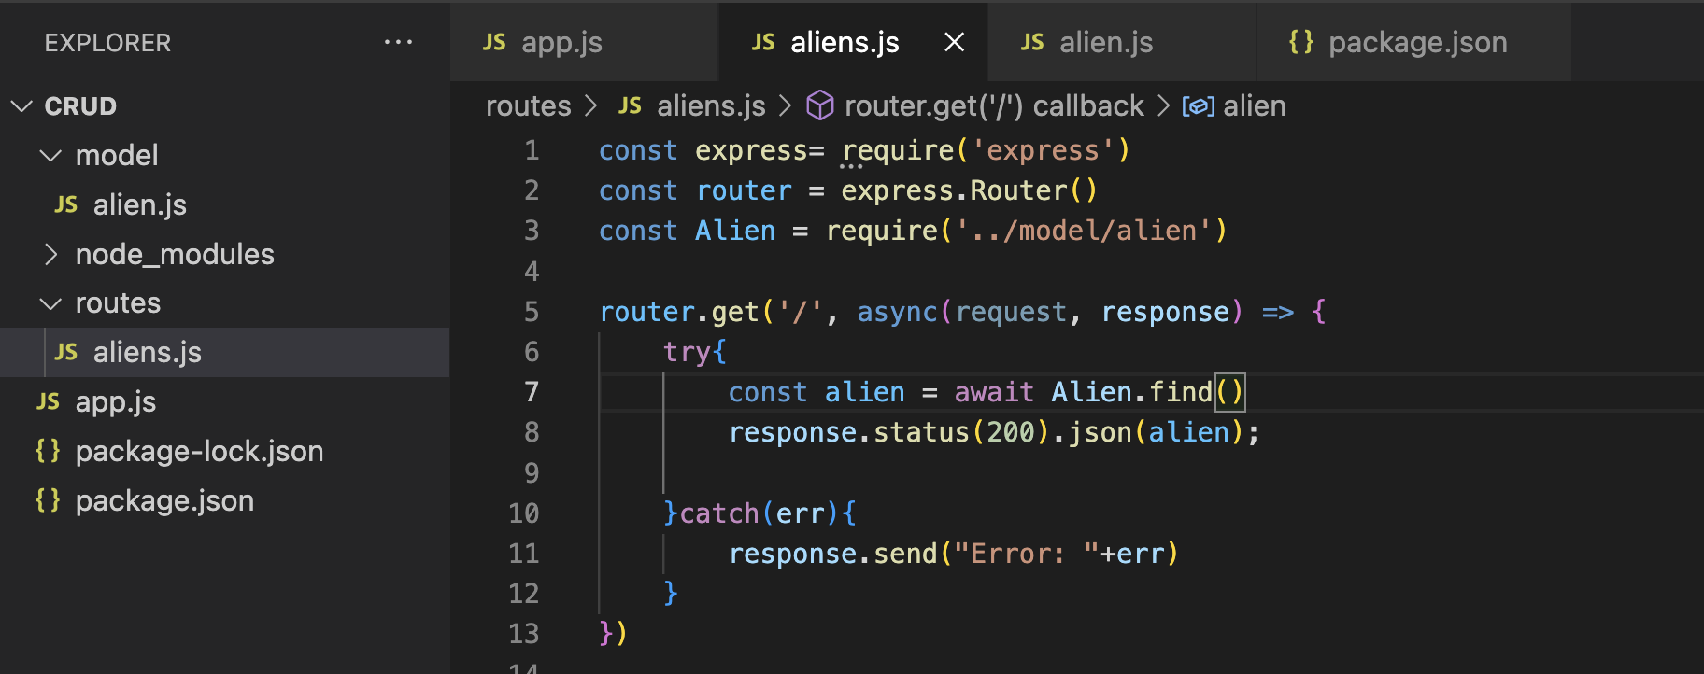

**Post method: “**http://localhost:9000/aliens**”**

